Crossroads International Church Singapore Dr. Rick Griffith
31 Dec 2017 Message 11 of 66
NLT 60 Minutes
Be United
Title
Book of 1 Kings

Topic: Unity
Subject: Why does unity sometimes lead to division?
Complement: Our unity is only as strong as our trust in Christ as our foundation.
Purpose: The listeners will put the Lord first by putting his Word first in the coming year.
Attribute: We worship the God of Unity
Reading: Phil 2:1-5
Song: O How Good It Is

Introduction

Interest: A building sinks when it lacks a good foundation. There must be unity between the seen and unseen parts. Likewise, God’s people need a strong foundation of unity rather than simply look good externally.
Mill Tower
(11 slides)

Need: Is your spiritual foundation getting stronger or weaker? If stronger, you are experiencing unity. If weaker, you are experiencing disunity or division.
Stronger?

Subject: Why does unity sometimes lead to division? What causes a unified people to become a divided people? Integral to unity is the foundation.
Subject
MI

Main Idea: Our unity is only as strong as our trust in Christ as our foundation.

Background: Today we’ll talk about the United Kingdom. It grew stronger and stronger from Saul to David to Solomon. We saw that 2 Samuel ended on a high note with Israel’s neighbors at bay, David and the people united and wealthy, and their trust in God unparalleled. God had even given him the Davidic Covenant.
UK
(4 slides)

Preview: But in 1 Kings we see that this foundation cracked beyond repair. Why did the unity between Israel and Judah divide?
Book
(3 slides)
Outline

Text: Today we will survey the entire book of 1 Kings.

(Why did unity lead to division for Solomon and sometimes unity leads to division for us?)

Idolatry leads to division (1 Kings 1–11; 971-931 BC).
MP
[History’s greatest king planted seeds to lose the kingdom by replacing God’s Law with idols.]

The establishment of Solomon as king in his anointing and purging the kingdom of rivals confirms God's loyalty to the Davidic Covenant (1 Kings 1–2).
2
(2 slides)
1
(3 slides)

Solomon’s anointing as king in response to his brother Adonijah's plot to seize the kingship verifies God's transfer of the Davidic Covenant from David to Solomon (1 Kings 1).

Solomon purged opposition to the throne in obedience to David's charge before his death to establish the kingdom in his hands (1 Kings 2).

David charged Solomon to obey the Law and execute rivals to his throne before his death (2:1-12).

Solomon purged the kingdom of four competitors (2:13-46).

Adonijah died trying to steal the kingdom by marrying David's attendant Abishag (2:13-25).

Abiathar's priesthood transferred to Zadok to fulfill the prophecy that Eli's line of priests would be cut off, thus showing God faithful to his word (2:26-27; cf. 1 Sam. 2:30-35).

Joab was executed for conspiring with Adonijah and killing Abner and Amasa (2:28-35; cf. 2 Sam. 3:22-30; 20:8-10).

Shimei was executed for disobeying Solomon's exile on him and for cursing David (2:36-46).

The rise of Solomon as king shows God's blessing upon him as the legitimate heir to the Davidic Covenant promises to instruct Israel in the benefits of following the Law (1 Kings 3–8).
3
(4 slides)
4
(3 slides)
6
(7 slides)
7
(3 slides)

Solomon's wisdom granted by God for obeying the Law and shown by judging between two prostitutes shows that God made him the rightful heir of the Davidic Covenant (1 Kings 3).

Solomon's administration through chief officials, governors, and officers receives international acclaim due to his great wisdom instructs Israel in the benefits of following the Law (1 Kings 4).

Solomon's temple was constructed, dedicated, and filled with God’s glory to affirm God's blessing on his obedience (1 Kings 5–8).
5
(10 slides)

Construction of the temple took seven years and employed thousands of Hiram's men and 213,000 Israelite workmen (1 Kings 5–6)!

In contrast, construction of Solomon's much larger palace took 13 years (7:1-12)!

Solomon’s… | Temple (1 Kings 6:1-2) | Palace (1 Kings 7:1-2)
Height | 30 cubits (13.5 meters) | 30 cubits (13.5 meters)
Width | 20 cubits (9 meters) | 50 cubits (23 meters)
Length | 60 cubits (27 meters) | 100 cubits (46 meters)
Construction | 966-959 BC (7 years; 1 Kings 6:38) | 959-946 BC (13 years; cf. Hag. 1:2-4)
Location | Rock of Moriah: place where Abraham offered Isaac (Gen. 22:14), later the threshing floor of Araunah (2 Sam. 24:16), and later the temple (1 Chron. 22:1; 2 Chron. 3:1) | Just south of the temple, which was next to the palace of Pharaoh’s daughter, wife of Solomon (2 Chron. 8:11)

Temple furnishings were built and brought into the temple (7:13-51).

After the return of the ark and Shekinah glory, Solomon dedicated the temple with a message and prayer which met both God's and the people's approval (1 Kings 8).
8
(3 slides)

The decline of Solomon from disobeying the Mosaic Covenant resulted in God opposing him and granting him only one tribe of his entire kingdom for a godless son (1 Kings 9–11).
9
(2 slides)

The LORD reaffirmed the Davidic Covenant to Solomon at the height of his life with a stern warning not to forsake the Mosaic Covenant (9:1-9).
Reading
(3 slides)

Despite his great wisdom, splendor, and God's warning, Solomon disobeyed the Law (9:10–11:8).
Warnings

He tried to pay Hiram 20 Israelite towns contrary to the Law (9:10-14; cf. Josh 1:3-4).

He enslaved Canaanites rather than exterminating them (9:15-28; cf. Exod 23:31-33).
10
(2 slides)

He amassed wealth contrary to the Law (10:1-25; cf. Deut 17:17b).
Gold

He multiplied horses contrary to the Law (10:26-29; cf. Deut 17:16).
Horses

He intermarried with foreigners contrary to the Law (11:1-2; cf. Exod 34:15-16).
11
(Title slide)

He multiplied wives contrary to the Law (11:3; cf. Deut 17:17a).
Wives
(4 slides)

He worshipped pagan gods and built them altars contrary to the Law (11:4-8; cf. Exod 34:15-16).

God disciplined Solomon’s disobedience to the Law by opposition and succession of his godless son Rehoboam who would rule only one tribe (11:9-43).

The LORD promised to judge Solomon's disobedience by having his heir rule only the tribe of Judah in a divided rather than a united kingdom (11:9-13).

God raised up both external and internal opposition to Solomon because of his disobedience to the Mosaic Covenant (11:14-40).
Bankrupt

External opposition came from Hadad the Edomite and Rezon the Zobahite, both unconquered enemies of David (11:14-25).

Internal opposition came from God's promise to Jeroboam, one of Solomon's own officials, that he would give him the northern nation of ten tribes (11:26-40).
Enemies

At Solomon's death after a 40-year rule his throne went to his godless son Rehoboam to rule only the tribe of Judah (11:41-43).
Death

The Kingdom in Tranquility  Transition  (10 slides) | Chapter 12  Split  of the Kingdom | The Kingdoms in Turmoil
God rules his people through a king:  SOLOMON |  | God speaks to his people through a prophet:  ELIJAH

The Significance of 1 Kings 12
Irving L. Jensen, Jensen’s Survey of the OT, 196

(Why did unity lead to division for kings after Solomon and sometimes unity leads to division for us?)
MPI

Ignoring God’s Word leads to division (1 Kings 12–22; 931-852 BC).
MP
[Division comes from his people ignoring what God has to say.]

The kingdom divided under the idolatry and evil reigns of Jeroboam and Rehoboam to remind Israel to obey the Law rather than repeat the sins of the past (1 Kings 12–14).
12
(5 slides)

The division of the kingdom due to Rehoboam's commitment to overwork the people teaches that God blesses righteous leadership but punishes evil (12:1-24).

God judged Jeroboam's evil reign in the first of nine dynasties in Israel for promoting idolatry to show God faithful to his word and committed to the Davidic Covenant (12:25–14:20).

Jeroboam protected his evil grasp on the northern tribes by making pagan altars at Bethel and Dan to keep his people from worship at Jerusalem (12:25-33).
Importing Paganism

God sent a prophet to warn Jeroboam of his evil ways who also became an example of the perils of disobedience, yet Jeroboam persisted in idolatry (1 Kings 13).
13
(4 slides)

Ahijah's prophecy to Jeroboam's wife of her son’s death and end of his dynasty vindicated the faithfulness of God’s word and commitment to the Davidic Covenant in Judah (14:1-20).
14
(3 slides)

God judged Rehoboam's evil reign of idolatry in the only dynasty in Judah by Shishak of Egypt stealing Solomon's gold temple shields to show the cost of defying the Law (14:21-31).

The mixed reigns of two kings in Judah saw more idolatry then its removal from the land (15:1-24).
15
(3 slides)

Abijam (Abijah) repeated the same idolatry committed by his father Rehoboam (15:1-8).

Asa’s good reign purged idolatry except at the high places and brought some reform to Judah (15:9-24).

God judged the evil reigns of five kings in Israel for disobeying the Mosaic Covenant (15:25–16:28).

Nadab committed evil and was judged by the loss of his dynasty (15:25-26).

Baasha (Second Dynasty) committed evil despite warnings from the prophet Jehu (15:27–16:7).
16
(7 slides)

Elah committed evil and was judged by the loss of his dynasty (16:8-14).

Zimri (Third Dynasty) murdered Baasha's entire family and then reigned only seven days before his suicide and was therefore judged by the loss of his dynasty (16:15-20).

Omri (Fourth Dynasty) built the city of Samaria but was judged for sinning worse than any previous king—especially for enticing Israel to idol worship (16:21-28).

The prophets Elijah and Micaiah confronted wicked Ahab of Israel to show the LORD's sovereignty over Baal (16:29–22:40).
Title
Title
Title
Title
Title

Ahab not only encouraged idolatry but after marrying the Sidonian princess Jezebel, he introduced Baal worship in Israel (16:29-34).
17
(22 slides)

God judged Ahab and Jezebel for their sin but protected Elijah from harm to teach that Yahweh—not Baal—is God (1 Kings 17–19).

Elijah predicted to Ahab a 3½-year drought but God miraculously fed Elijah by ravens and a widow to show that Yahweh—not Baal—is God (1 Kings 17).

Elijah revealed God’s power at Carmel and murdered Baal's prophets to show Ahab and Jezebel that Yahweh—not Baal— deserves worship (1 Kings 18).
18
(35 slides)

Jezebel tried to kill Elijah but God gave him food, an appearance, and a new disciple to show that Yahweh protected Elijah but Baal was silent (1 Kings 19).
19
(2 slides)

Ahab defeated Syria at Samaria and Aphek but was prophesied death because he spared Ben-Hadad instead of trusting God above false gods (1 Kings 20).
20
(2 slides)

The result of Ahab’s murder of Naboth and seizure of his vineyard inheritance was God’s message that his family line would be cut off after his son’s rule (1 Kings 21).
24
(2 slides)

The way Ahab abused his authority was to let Jezebel seize Naboth’s vineyard and kill him (21:1-16).

The result of Ahab’s abuse of his authority was God’s announcement that his family line would be cut off after his son rules (21:17-29).

God judged Ahab by death at Ramoth-Gilead to fulfill Micaiah and Elijah’s prophecies since Ahab trusted powerless Baal prophets instead of God’s true prophet (22:1-40).
22
(2 slides)

Jehoshaphat's good reign in Judah purged the male shrine prostitutes and lacked only removal of the high places (22:41-50).

Ahaziah's evil reign in Israel continued the Baal worship begun by Ahab (22:51-53). NOTE: The rest of his reign is completed in 2 Kings 1.
God First
(3 slides)
Prayer

(Why does unity sometimes lead to division?)
Subj

Conclusion

Our unity is only as strong as our trust in Christ as our foundation (MI).
MI

But how do we express that trust in our foundation to maintain unity (Main Points)?

Unity is often lost due to idolatry (1 Kings 1–11)—so remove your idols!
MPI

God’s work destabilizes when we ignore God’s Word (1 Kings 12–22)—so listen to him daily!
MPII

Exhortation: How can you put the Lord first by putting his Word first in the coming year? Put him first by reading his Word daily by downloading the YouVersion app.

Prayer

Preliminary Questions

Verses Questions

Context: What did the author record just prior to this passage?

Purpose: Why is this passage in the Bible?

Background: What historical context helps us understand this passage?

Questions

Tentative Main Ideas

Text

Illustrations That Apply

Text

Old Testament Survey Notes

1 Kings

Division of the Kingdom

Late United Kingdom |  |  | Early Divided Kingdom
Chapters 1–11 |  |  | Chapters 12–22
Solomon |  |  | Split
Mostly Obedience |  |  | Mostly Disobedience
Yahweh Worship |  |  | Idol Worship
Kingdom in Tranquility |  |  | Kingdoms in Turmoil
Single Capital: Jerusalem |  |  | Israel’s Capital: Samaria  Judah’s Capital: Jerusalem
40 Years  (971-931 BC) |  |  | 80 Years  (931-852 BC)
Established: Purging  1–2 | Rise: Obedience  3–8 | Decline:  Disobedience  9–11 | “J & R”  Kings  12–14 | Other  Kings  15:1–16:28 | Ahab vs. Elijah  16:29–22:40 | Other  Kings  22:41-53

Key Word: Division

Key Verse: “But I will not take the whole kingdom out of Solomon’s hand; I have made him ruler all the days of his life for the sake of David my servant, whom I chose and who observed my commands and statutes. I will take the kingdom from his son’s hands and give you [Jeroboam] ten tribes” (1 Kings 11:34-35).

Summary Statement:
Solomon’s prosperity from loyalty to the Law ends in disobedience that causes the division of the kingdom with mostly evil kings in Israel and Judah to remind Judah of God's loyalty to the Davidic Covenant and its own need to obey the Law.

Application:

The test of a true servant of God is the ability to end well.

Discerning people of God learn from the mistakes of their predecessors and do not repeat these sins themselves.

1 Kings

Introduction

I. Title First and Second Kings originally comprised only one book in the Hebrew canon called "Kings" (~ykil,m,) after the first word in 1:1 ("Now King"; &l,M,h;w>). However, this single scroll was arbitrarily divided in the Septuagint (250 BC) since the Greek required a greater amount of scroll space. The Septuagint titles were Third and Fourth Kingdoms (since 1 and 2 Samuel were designated 1 and 2 Kingdoms). Jerome called 1 and 2 Kings "The Book of the Kings" about six centuries later. These titles are appropriate as these books record and interpret the reign of every king of Israel and Judah except Saul (David has brief mention in 1 Kings 1:1–2:12).

II. Authorship

A. External Evidence: Jewish tradition ascribes the authorship of the Books of Kings to Jeremiah, and this gains weight from literary parallels between this record and the prophecy of Jeremiah.

B. Internal Evidence: The prophetic-like descriptions of Israel's apostasy indicate that the author was a prophet/historian. Also, this compiler had several historical documents at his fingertips: “the book of the acts of Solomon” (1 Kings 11:41), “the book of the chronicles of the kings of Israel” (1 Kings 14:19), and “the book of the chronicles of the kings of Judah” (1 Kings 14:29; 15:7). These books may be attributed to the official secretary Shebna and/or the official recorder Joah, son of Asaph (2 Kings 18:18; cf. Isa. 36:11). Parallels between 2 Kings 18–20 and Isaiah 36–39 also reveal that Isaiah's scroll also was a source. No firm evidence exists to refute the tradition that Jeremiah authored the Book of Kings.

III. Circumstances

A. Date: Three lines of evidence indicate that First Kings and even most of Second Kings were written before the Babylonian Captivity (586 BC). The ark still resided in Solomon's temple (1 Kings 8:8), Israel was still in rebellion against Judah (1 Kings 12:19), and Samaria's idolatry persisted even after its resettlement (2 Kings 17:34, 41). However, the final two chapters of Second Kings record up to 26 years after this captivity and may have been recorded by a Jewish captive in Babylon or by Jeremiah himself, who would have been at least 84 years old.

First Kings covers a period of history totaling 120 years, beginning in 971 BC with the inauguration of Solomon and ending in 852 BC near the end of Ahaziah's reign. The year 931 BC marks the most significant date when Solomon's kingdom split into the northern nation of Israel and the southern kingdom of Judah after his death.

Second Kings picks up at 852 BC and traces the account through the falls of Samaria (722 BC) and Jerusalem (586 BC) until the release of Jehoiachin in Babylon in 560 BC—a period of over 293 years.

B. Recipients: The Book of Kings was written to the remaining kingdom of Judah before (1 Kings 1–2 Kings 23) and after (2 Kings 24–25) its own exile in Babylon.

C. Occasion: Jeremiah's prophecy and Lamentations record his eyewitness account of Babylon's siege and destruction of Jerusalem for the nation's sins. In addition to his own prophetic word, the Holy Spirit moved him to record an historical compilation to give the context and justification for God's judgments on these two nations. The leaders and the people sinned through ungodliness and idolatry, and, true to the curses of Deuteronomy 28, God gave them the consequences of their disobedience. Therefore, the purpose of the record is to show how the welfare of Israel and Judah depended upon the faithfulness of the king and people to the covenant of Moses to teach the exiles to learn from the past mistakes of their ancestors. In large part this purpose was accomplished in history as Israel has not since the Captivity had a problem with idolatry.

IV. Characteristics

A. The Books of Kings record more national leaders than any book in Scripture.

B. Kings and Chronicles overlap in their records of the kingdom era, but have some notable differences in emphasis (Constable, BKC, 1:484; Merrill, BKC, 1:591; Zuck, BTOT, 162):

 | Kings | Chronicles
Kings of… | Israel and Judah | Judah (almost exclusively)
Elements | Royal/prophetic | Priestly (temple and worship)
Evaluation | Based on Mosaic Law | Based on David/worship of Yahweh
Purpose | Ethical: Judging both nations | Covenant: Blessing Judah due to David
Author | Jeremiah the prophet/priest | Ezra the priest
Faith | Man's faithlessness | God's faithfulness
Outlook | Negative: rebellion/tragedy | Positive: hope amidst apostasy/tragedy
Recipients | Exilic Jews (ca. 550 BC) | Postexilic Jews (ca. 440 BC)
Chronology | 971-586 BC | 1011-538 BC
Emphasis | Political: emphasizes the throne | Spiritual: emphasizes the temple
Content | Historical | Theological
Attributes | God's justice | God's grace
Protagonist | Human responsibility | Divine sovereignty

Memory Acronym: KEEP A FORCE CAP (using the first letters of each category above)

C. Reconciling the chronology of the kings in Kings and Chronicles perplexed scholars for centuries until the work of Seventh-day Adventist scholar Edwin R. Thiele (pronounced Teé-lee) in the 20th century. His books, A Chronology of the Hebrew Kings (Grand Rapids: Zondervan, 1977) and especially The Mysterious Numbers of the Hebrew Kings (rev. ed.; Chicago: Univ. of Chicago Press, 1983), have insightfully answered several chronological difficulties, particularly of Judah (Constable, BKC, 1:484). Thiele notes that differences in dating can be attributed to various factors (cf. OTS, 231-32):

1. Co-regencies and vice-regencies often answer how chronologies overlap.

2. Judah and Israel used two different methods to determine when a king's reign began, and both nations changed these methods at least once!

3. Judah and Israel used different calendars, beginning their years at different times!

4. The names of kings can often be confusing:

a. Some kings had the same name (two kings had the names Jeroboam, Jehoram, Jehoahaz, Ahaziah, etc.). Once two kings with the same name even reigned simultaneously (Jehorams of both Israel and Judah)!

b. Two different names sometimes referred to the same king (e.g., Uzziah = Azariah, Abijah = Abijam, Joram = Jehoram, Joash = Jehoash).

c. Also, 24 of the 39 kings had names beginning with "A" or "J."

Therefore, the chronologies are very difficult to harmonize exactly; however, in most cases the various systems differ by only one or two years.

D. One difficult verse is 1 Kings 4:21, which states, “And Solomon ruled over all the kingdoms from the River to the land of the Philistines, as far as the border of Egypt. These countries brought tribute and were Solomon’s subjects all his life.” Is this the fulfillment of the promise to Abraham in Genesis 15:18 that his descendants would possess the land from the Wadi of Egypt to the Euphrates River (modern Iraq)? The following shows that this was only a partial fulfillment of this promise so that a future, full fulfillment yet awaits us:
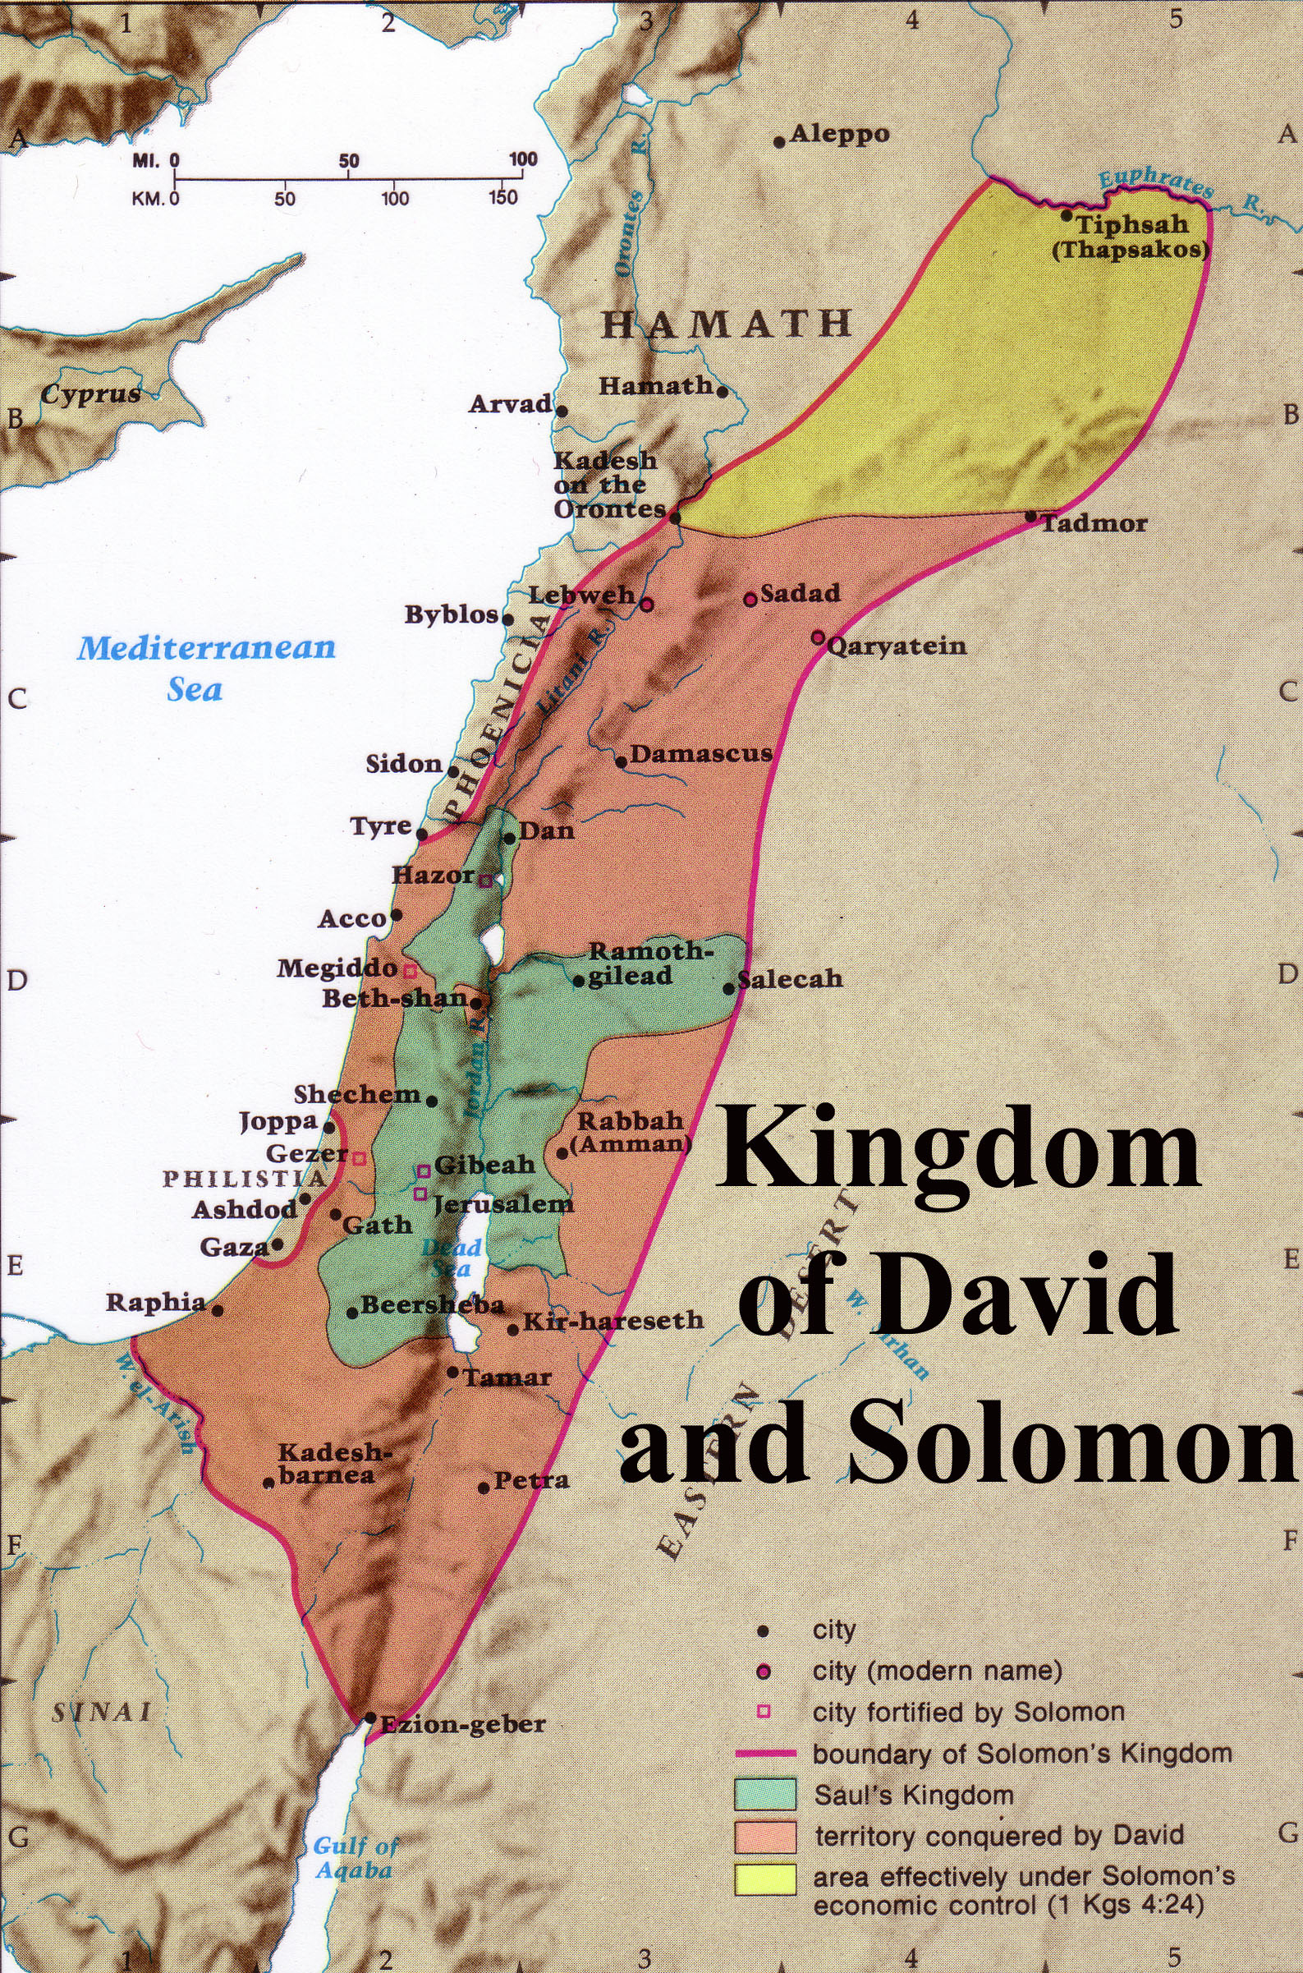
1. God clarified this promise to Abraham in Ezekiel by saying that this covenant with Jerusalem is an eternal covenant (Gen. 17:8; cf. Ezek. 16:1, 60).

2. Solomon only collected tribute from these areas, which is different than saying that Israel possessed this land and lived in it (“I will give this land,” Gen. 15:18).

3. The time of fulfillment is after exile and national repentance (Deut. 30:2, 6, 8, 10; Jer. 17:24-27; 18:7-10) that would take place after the return from Babylon (Zech. 10:9-10), which was long after Solomon’s time. This will not occur until the Second Coming of Christ (Rom. 11:26-27).

Argument

The Book of 1 Kings records the first part of the history of the kings of Israel and Judah but does so with a purpose. The author's motive seems to be an ethical one—to convince his readers from the lessons of the past that God blesses obedience to his covenant but judges disobedience. This is observable in the greater part of the reign of Solomon (1 Kings 1–11), who prospers in a United Kingdom as he obeys (1 Kings 1–8) but loses the kingdom after his sins of materialism, intermarriage, and especially idol worship (1 Kings 9–11). After the kingdom divides, both the north and the south experience instability and division depending on the obedience of each king (1 Kings 12–22). The book also shows God's commitment to the Davidic Covenant through Solomon and the kings of Judah who retain only one dynasty in contrast to the four dynasties of the northern kingdom that do not possess the promise of the Davidic Covenant.

Synthesis

Early divided kingdom covenant disobedience Division of the Kingdom

1–11 Solomon's prosperity from obedience
1–2 Establishment
1 Anointed king
2 Purges opposition
3–8 Rise: obedience
3 Wisdom
4 Administration
5–8 Temple
9–11 Decline: disobedience
9:1-9 Davidic Covenant reaffirmed
9:10–11:8 Disobedience
11:9-43 Judgment: Opposition & Rehoboam
12–22 Early divided kingdom Key to Morality of Kings
12–14 Jeroboam/Rehoboam I = Israel (all bad kings)
12:1-24 Division over work J = Judah (good kings in bold)
12:25–14:20 Jeroboam (1; I)–idolatry (1) = Israel dynasties
14:21-31 Rehoboam (J)–idolatry
15:1-8 Abijam (Abijah; J)
15:9-24 Asa (J)
15:25-26 Nadab (I)
15:27–16:7 Baasha (2; I)
16:8-14 Elah (I)
16:15-20 Zimri (3; I)
16:21-28 Omri (4; I)
16:29–22:40 Ahab (I) vs. Elijah/Micaiah
16:29-34 Idolatry/Baal worship
17–19 Judgment (YHWH is God!)
17 Drought vs. ravens/widow
18 Mt. Carmel
19 Murder thwarted vs. God's protection
20 Victory over Syria
21 Naboth
22:1-40 Death at Ramoth-Gilead
22:41-50 Jehoshaphat (J)
22:51-53 Ahaziah (I)

Outline

Summary Statement for the Book
Solomon’s prosperity from loyalty to the Law ends in disobedience that causes the division of the kingdom with mostly evil kings in Israel and Judah to remind Judah of God's loyalty to the Davidic Covenant and its own need to obey the Law.

The end of Solomon’s united and prosperous kingdom due to his idolatry reminds Judah of God's loyalty to the Davidic Covenant and its need to obey the Law (1 Kings 1–11; 971-931 BC).

The establishment of Solomon as king in his anointing and purging the kingdom of rivals confirms God's loyalty to the Davidic Covenant (1 Kings 1–2).

Solomon’s anointing as king in response to his brother Adonijah's plot to seize the kingship verifies God's transfer of the Davidic Covenant from David to Solomon (1 Kings 1).

Solomon purged opposition to the throne in obedience to David's charge before his death to establish the kingdom in his hands (1 Kings 2).

David charged Solomon to obey the Law and execute rivals to his throne before his death (2:1-12).

Solomon purged the kingdom of four competitors (2:13-46).

Adonijah died trying to steal the kingdom by marrying David's attendant Abishag (2:13-25).

Abiathar's priesthood transferred to Zadok to fulfill the prophecy that Eli's line of priests would be cut off, thus showing God faithful to his word (2:26-27; cf. 1 Sam. 2:30-35).

Joab was executed for conspiring with Adonijah and killing Abner and Amasa (2:28-35; cf. 2 Sam. 3:22-30; 20:8-10).

Shimei was executed for disobeying Solomon's exile on him and for cursing David (2:36-46).

The rise of Solomon as king shows God's blessing upon him as the legitimate heir to the Davidic Covenant promises to instruct Israel in the benefits of following the Law (1 Kings 3–8).

Solomon's wisdom granted by God for obeying the Law and shown by judging between two prostitutes shows that God made him the rightful heir of the Davidic Covenant (1 Kings 3).

Solomon's administration through chief officials, governors, and officers receives international acclaim due to his great wisdom instructs Israel in the benefits of following the Law (1 Kings 4).

Solomon's temple was constructed, dedicated, and filled with God’s glory to affirm God's blessing on his obedience (1 Kings 5–8).

Construction of the temple took seven years and employed thousands of Hiram's men and 213,000 Israelite workmen (1 Kings 5–6)!

In contrast, construction of Solomon's much larger palace took 13 years (7:1-12)!

Solomon’s… | Temple (1 Kings 6:1-2) | Palace (1 Kings 7:1-2)
Height | 30 cubits (13.5 meters) | 30 cubits (13.5 meters)
Width | 20 cubits (9 meters) | 50 cubits (23 meters)
Length | 60 cubits (27 meters) | 100 cubits (46 meters)
Construction | 966-959 BC (7 years; 1 Kings 6:38) | 959-946 BC (13 years; cf. Hag. 1:2-4)
Location | Rock of Moriah: place where Abraham offered Isaac (Gen. 22:14), later the threshing floor of Araunah (2 Sam. 24:16), and later the temple (1 Chron. 22:1; 2 Chron. 3:1) | Just south of the temple, which was next to the palace of Pharaoh’s daughter, wife of Solomon (2 Chron. 8:11)

Temple furnishings were built and brought into the temple (7:13-51).

After the return of the ark and Shekinah glory, Solomon dedicated the temple with a message and prayer which met both God's and the people's approval (1 Kings 8).

The decline of Solomon from disobeying the Mosaic Covenant resulted in God opposing him and granting him only one tribe of his entire kingdom for a godless son (1 Kings 9–11).

The LORD reaffirmed the Davidic Covenant to Solomon at the height of his life with a stern warning not to forsake the Mosaic Covenant (9:1-9).

Despite his great wisdom, splendor, and God's warning, Solomon disobeyed the Law (9:10–11:8).

He tried to pay Hiram 20 Israelite towns contrary to the Law (9:10-14; cf. Josh 1:3-4).

He enslaved Canaanites rather than exterminating them (9:15-28; cf. Exod 23:31-33).

He amassed wealth contrary to the Law (10:1-25; cf. Deut 17:17b).

He multiplied horses contrary to the Law (10:26-29; cf. Deut 17:16).

He intermarried with foreigners contrary to the Law (11:1-2; cf. Exod 34:15-16).

He multiplied wives contrary to the Law (11:3; cf. Deut 17:17a).

He worshipped pagan gods and built them altars contrary to the Law (11:4-8; cf. Exod 34:15-16).

God disciplined Solomon’s disobedience to the Law by opposition and succession of his godless son Rehoboam who would rule only one tribe (11:9-43).

The LORD promised to judge Solomon's disobedience by having his heir rule only the tribe of Judah in a divided rather than a united kingdom (11:9-13).

God raised up both external and internal opposition to Solomon because of his disobedience to the Mosaic Covenant (11:14-40).

External opposition came from Hadad the Edomite and Rezon the Zobahite, both unconquered enemies of David (11:14-25).

Internal opposition came from God's promise to Jeroboam, one of Solomon's own officials, that he would give him the northern nation of ten tribes (11:26-40).

At Solomon's death after a 40-year rule his throne went to his godless son Rehoboam to rule only the tribe of Judah (11:41-43).

The Kingdom in Tranquility | Chapter 12  Split  of the Kingdom | The Kingdoms in Turmoil
God rules his people through a king:  SOLOMON |  | God speaks to his people through a prophet:  ELIJAH

The Significance of 1 Kings 12
Irving L. Jensen, Jensen’s Survey of the OT, 196

The unstable divided kingdom under early kings of Israel and Judah by ignoring the Law reminds Israel to obey the Law—not repeat the past (1 Kings 12–22; 931-852 BC).

The kingdom divided under the idolatry and evil reigns of Jeroboam and Rehoboam to remind Israel to obey the Law rather than repeat the sins of the past (1 Kings 12–14).

The division of the kingdom due to Rehoboam's commitment to overwork the people teaches that God blesses righteous leadership but punishes evil (12:1-24).

God judged Jeroboam's evil reign in the first of nine dynasties in Israel for promoting idolatry to show God faithful to his word and committed to the Davidic Covenant (12:25–14:20).

Jeroboam protected his evil grasp on the northern tribes by making pagan altars at Bethel and Dan to keep his people from worship at Jerusalem (12:25-33).

God sent a prophet to warn Jeroboam of his evil ways who also became an example of the perils of disobedience, yet Jeroboam persisted in idolatry (1 Kings 13).

Ahijah's prophecy to Jeroboam's wife of her son’s death and end of his dynasty vindicated the faithfulness of God’s word and commitment to the Davidic Covenant in Judah (14:1-20).

Ahijah predicted to Jeroboam's wife her son’s death and end of his dynasty to show God’s fidelity to his word and commitment to the Davidic Covenant in Judah (14:1-20).

God judged Rehoboam's evil reign of idolatry in the only dynasty in Judah by Shishak of Egypt stealing Solomon's gold temple shields to show the cost of defying the Law (14:21-31).

The mixed reigns of two kings in Judah saw more idolatry then its removal from the land (15:1-24).

Abijam (Abijah) repeated the same idolatry committed by his father Rehoboam (15:1-8).

Asa’s good reign purged idolatry except at the high places and brought some reform to Judah (15:9-24).

God judged the evil reigns of five kings in Israel for disobeying the Mosaic Covenant (15:25–16:28).

Nadab committed evil and was judged by the loss of his dynasty (15:25-26).

Baasha (Second Dynasty) committed evil despite warnings from the prophet Jehu (15:27–16:7).

Elah committed evil and was judged by the loss of his dynasty (16:8-14).

Zimri (Third Dynasty) murdered Baasha's entire family and then reigned only seven days before his suicide and was therefore judged by the loss of his dynasty (16:15-20).

Omri (Fourth Dynasty) built the city of Samaria but was judged for sinning worse than any previous king—especially for enticing Israel to idol worship (16:21-28).

The prophets Elijah and Micaiah confronted wicked Ahab of Israel to show the LORD's sovereignty over Baal (16:29–22:40).

Ahab not only encouraged idolatry but after marrying the Sidonian princess Jezebel, he introduced Baal worship in Israel (16:29-34).

God judged Ahab and Jezebel for their sin but protected Elijah from harm to teach that Yahweh—not Baal—is God (1 Kings 17–19).

Elijah predicted to Ahab a 3½-year drought but God miraculously fed Elijah by ravens and a widow to show that Yahweh—not Baal—is God (1 Kings 17).

Elijah revealed God’s power at Carmel and murdered Baal's prophets to show Ahab and Jezebel that Yahweh—not Baal— deserves worship (1 Kings 18).

Jezebel tried to kill Elijah but God gave him food, an appearance, and a new disciple to show that Yahweh protected Elijah but Baal was silent (1 Kings 19).

Ahab defeated Syria at Samaria and Aphek but was prophesied death because he spared Ben-Hadad instead of trusting God above false gods (1 Kings 20).

The result of Ahab’s murder of Naboth and seizure of his vineyard inheritance was God’s message that his family line would be cut off after his son’s rule (1 Kings 21).

The way Ahab abused his authority was to let Jezebel seize Naboth’s vineyard and kill him (21:1-16).

The result of Ahab’s abuse of his authority was God’s announcement that his family line would be cut off after his son rules (21:17-29).

God judged Ahab by death at Ramoth-Gilead to fulfill Micaiah and Elijah’s prophecies since Ahab trusted powerless Baal prophets instead of God’s true prophet (22:1-40).

Jehoshaphat's good reign in Judah purged the male shrine prostitutes and lacked only removal of the high places (22:41-50).

Ahaziah's evil reign in Israel continued the Baal worship begun by Ahab (22:51-53). NOTE: The rest of his reign is completed in 2 Kings 1.

Note: For a helpful guide in correlating the various accounts in the lives of the kings of Israel and Judah, consult the following harmony. It generally places the narratives chronologically in parallel columns but is strongest in its literary comparisons (see a page of Newsome on p. 267b).

Newsome, James D., Jr. A Synoptic Harmony of Samuel, Kings, and Chronicles: With Related Passages from Psalms, Isaiah, Jeremiah, and Ezra. Grand Rapids: Baker, 1986. 275 pp.

The Divided Kingdoms
Adapted and expanded from Huang Sabin, OT Made Simple;
Andrew E. Hill & John H. Walton, A Survey of the Old Testament, 3rd ed., 290

Israel | Judah
North | South
10 tribes | 2 tribes
9 ruling dynasties | 1 ruling dynasty*
20 kings** | 19 kings, 1 queen
20 evil kings | 12 evil kings/queens
0 good kings | 8 good kings
7 assassinations | 5 assassinations
1 suicide | 0 suicides
1 “stricken by God” | 2 “stricken by God”
0 kings exiled to foreign lands | 3 kings exiled to foreign lands
First king: Jeroboam | First king: Rehoboam
Last king: Hoshea | Last king: Zedekiah
Lasted 209 years | Lasted 345 years
People exiled in 722 BC | People exiled from 605-586 BC
Exiled to Assyria’s conquered lands | Exiled to Babylon
Never returned to land of Israel | Remnant returned after 70 years
Only tribes migrating to Judah returned | Returned in 538 BC

* Queen Athaliah of Judah interrupted the Davidic dynasty but it resumed after her death so she acted more as a parenthesis as opposed to the elimination of the previous dynasties in Israel.

** The competing reign of Tibni for three of Omri’s years is included here.

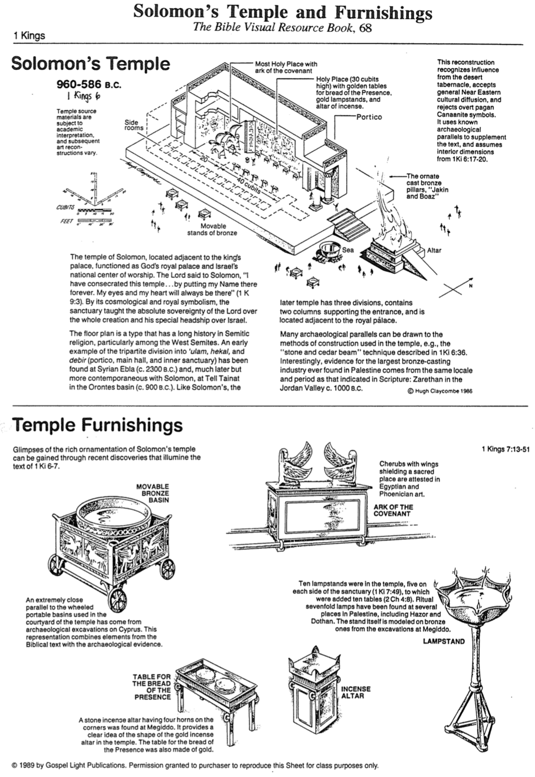
Solomon’s Temple and Furnishings

The Bible Visual Resource Book, 68

Possible Locations of Solomon’s Temple

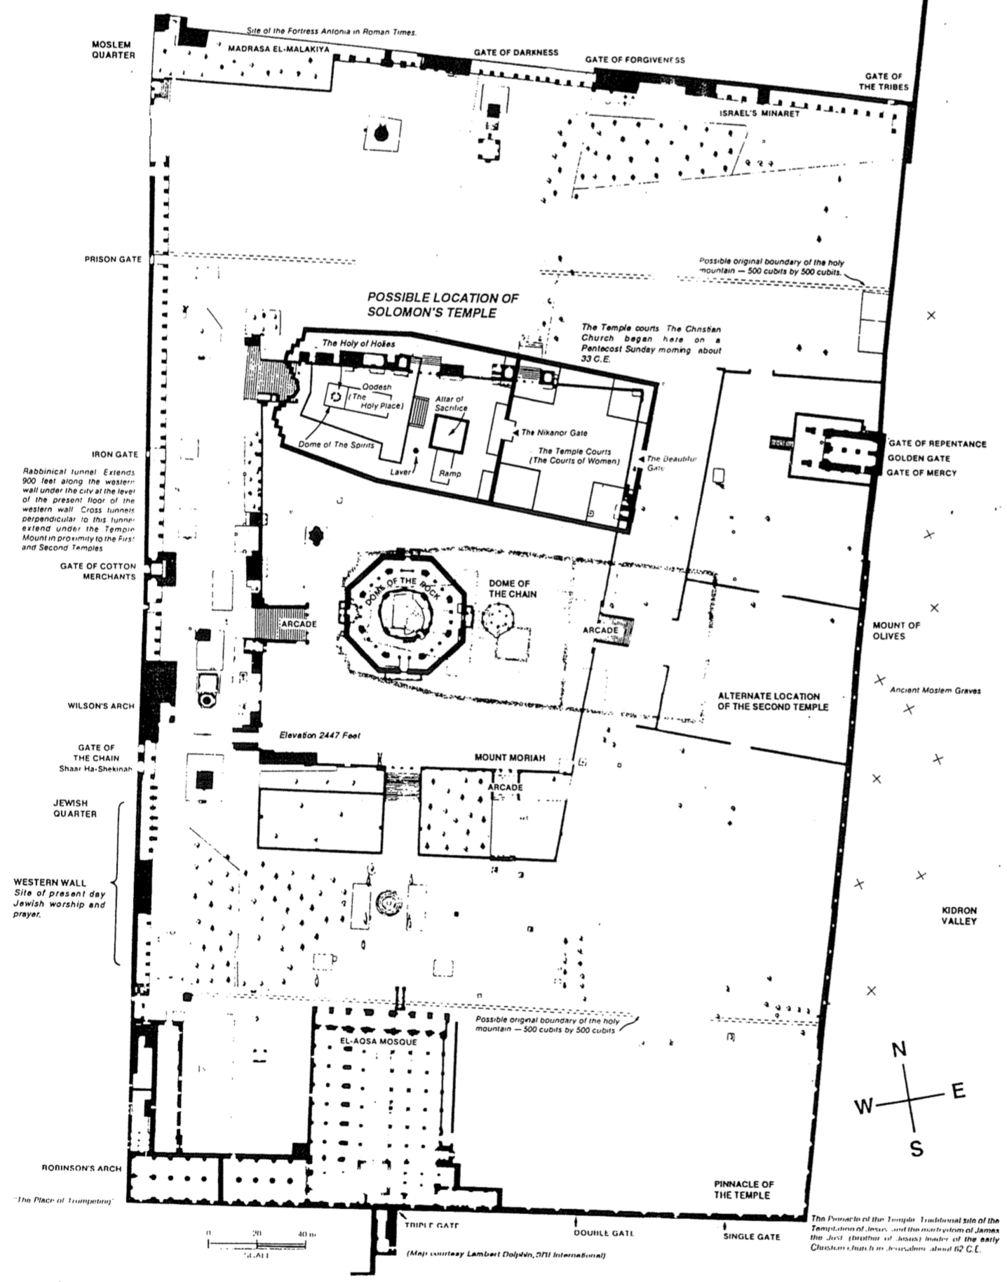
Geography of the Divided Kingdom
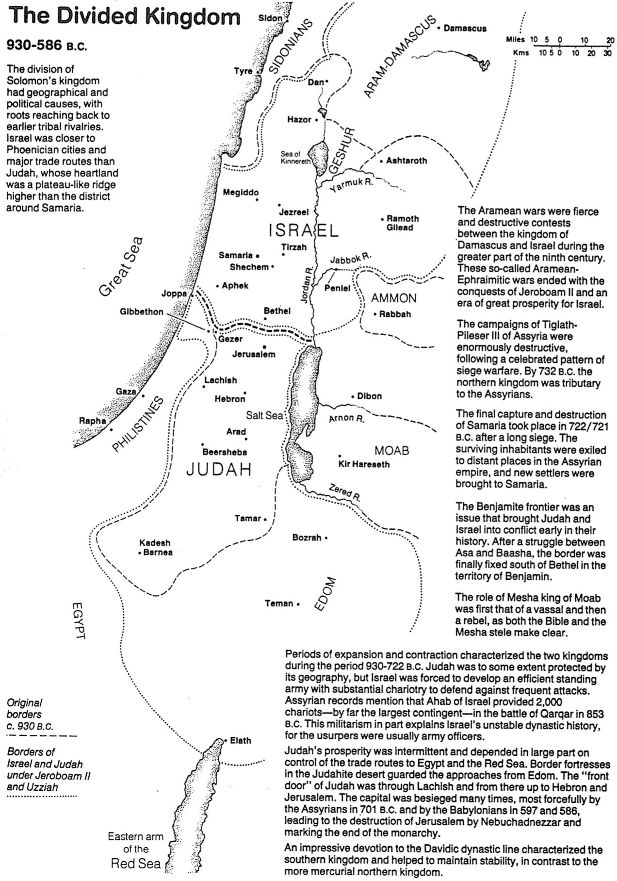
The Bible Visual Resource Book, 75

Chart of Old Testament Kings and Prophets

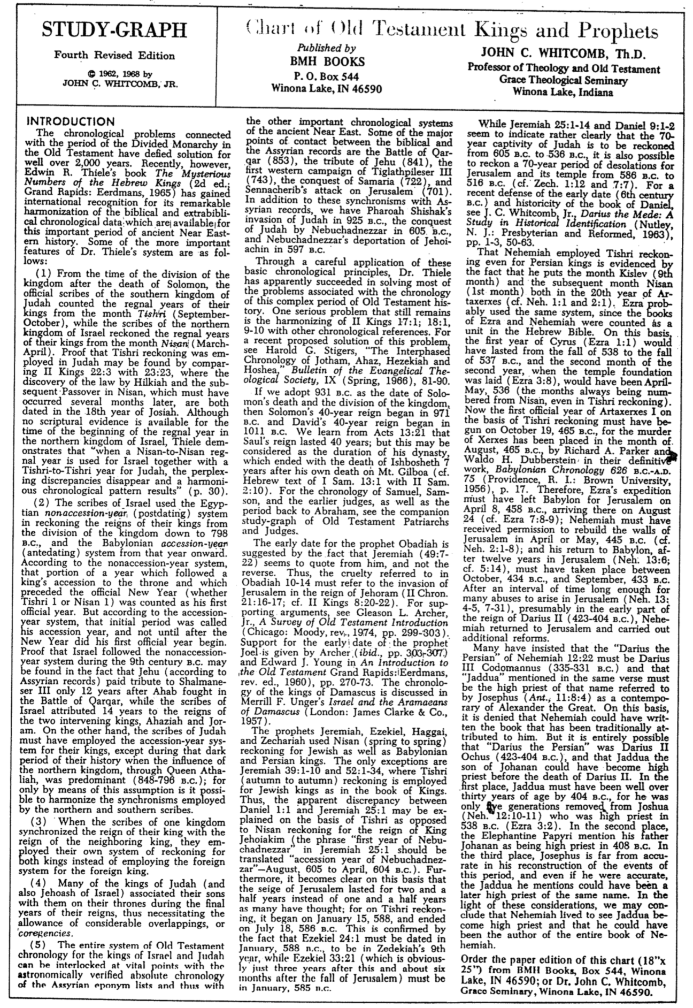
John C. Whitcomb (1 of 2)

(It’s OK to cover the above title)
Chart of Old Testament Kings and Prophets
John C. Whitcomb (2 of 2)
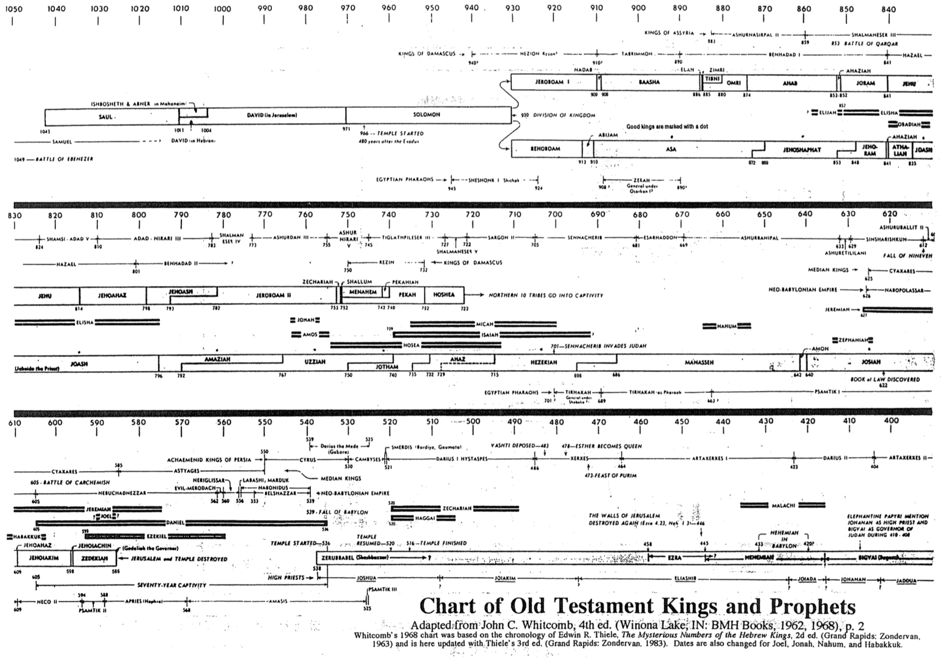

(It’s OK to cover the above title)
Be United
Book of 1 Kings

Exegetical Outline (Steps 2-3)

Exegetical Idea:
The reason Solomon’s prosperity ended in disgrace and the kingdom divided with mostly evil kings in Israel and Judah was to remind Judah of God's loyalty to the Davidic Covenant and its own need to obey the Law.

The reason Solomon’s united and prosperous kingdom failed was because of his idolatry instead of seeing God's loyalty to the Davidic Covenant and his need to obey the Law (1 Kings 1–11; 971-931 BC).

The establishment of Solomon as king in his anointing and purging the kingdom of rivals confirmed God's loyalty to the Davidic Covenant (1 Kings 1–2).

The rise of Solomon as king shows God's blessing upon him as the legitimate heir to the Davidic Covenant promises to instruct Israel in the benefits of following the Law (1 Kings 3–8).

The decline of Solomon from disobeying the Mosaic Covenant resulted in God opposing him and granting him only one tribe of his entire kingdom for a godless son (1 Kings 9–11).

The reason for the unstable early divided kingdom was because the kings ignored the Law to teach Israel not repeat their mistakes (1 Kings 12–22; 931-852 BC).

The kingdom divided under the idolatry and evil reigns of Jeroboam and Rehoboam to remind Israel to obey the Law rather than repeat the sins of the past (1 Kings 12–14).

The mixed reigns of two kings in Judah saw more idolatry then its removal from the land (15:1-24).

God judged the evil reigns of five kings in Israel for disobeying the Mosaic Covenant (15:25–16:28).

The prophets Elijah and Micaiah confronted wicked Ahab of Israel to show the LORD's sovereignty over Baal (16:29–22:40).

Jehoshaphat's good reign in Judah purged the male shrine prostitutes and lacked only removal of the high places (22:41-50).

The beginning of Ahaziah's evil reign in Israel continued the Baal worship begun by his father Ahab (22:51-53). NOTE: The rest of his reign is completed in 2 Kings 1.

Purpose or Desired Listener Response (Step 4)
The listeners will put the Lord first by putting his Word first in the coming year.

Homiletical Outline (Cyclical inductive form)

Introduction

Interest: Things sink without a good foundation.

Need: Is your spiritual foundation getting stronger or weaker?

Subject: Why does unity sometimes lead to division? What causes this to happen? The vital part is the foundation.

Main Idea: Our unity is only as strong as our trust in Christ as our foundation.

Background: The United Kingdom grew stronger and stronger from Saul to David to Solomon. We saw that 2 Samuel ended on a high note with Israel’s neighbors at bay, David and the people united and wealthy, and their trust in God unparalleled.

Preview: But in 1 Kings we see that this foundation cracked beyond repair. Why did the unity between Israel and Judah divide?

Text: Today we will survey the entire book of 1 Kings.

(Why did unity lead to division for Solomon and sometimes unity leads to division for us?)

Idolatry leads to division (1 Kings 1–11; 971-931 BC).

The establishment of Solomon as king in his anointing and purging the kingdom of rivals confirms God's loyalty to the Davidic Covenant (1 Kings 1–2).

The rise of Solomon as king shows God's blessing upon him as the legitimate heir to the Davidic Covenant promises to instruct Israel in the benefits of following the Law (1 Kings 3–8).

The decline of Solomon from disobeying the Mosaic Covenant resulted in God opposing him and granting him only one tribe of his entire kingdom for a godless son (1 Kings 9–11).

(Why did unity lead to division for kings after Solomon and sometimes unity leads to division for us?)

Ignoring God’s Word leads to division (1 Kings 12–22; 931-852 BC).

The kingdom divided under the idolatry and evil reigns of Jeroboam and Rehoboam to remind Israel to obey the Law rather than repeat the sins of the past (1 Kings 12–14).

The mixed reigns of two kings in Judah saw more idolatry then its removal from the land (15:1-24).

God judged the evil reigns of five kings in Israel for disobeying the Mosaic Covenant (15:25–16:28).

The prophets Elijah and Micaiah confronted wicked Ahab of Israel to show the LORD's sovereignty over Baal (16:29–22:40).

Jehoshaphat's good reign in Judah purged the male shrine prostitutes and lacked only removal of the high places (22:41-50).

Ahaziah's evil reign in Israel continued the Baal worship begun by Ahab (22:51-53).

(Why does unity sometimes lead to division?)

Conclusion

Our unity is only as strong as our trust in Christ as our foundation (MI).

But how do we express that trust in our foundation to maintain unity (Main Points)?

Unity is often lost due to idolatry (1 Kings 1–11)—so remove your idols!

God’s work destabilizes when we ignore God’s Word (1 Kings 12–22)—so listen to him daily!

Exhortation: How can you put the Lord first by putting his Word first in the coming year?

Prayer

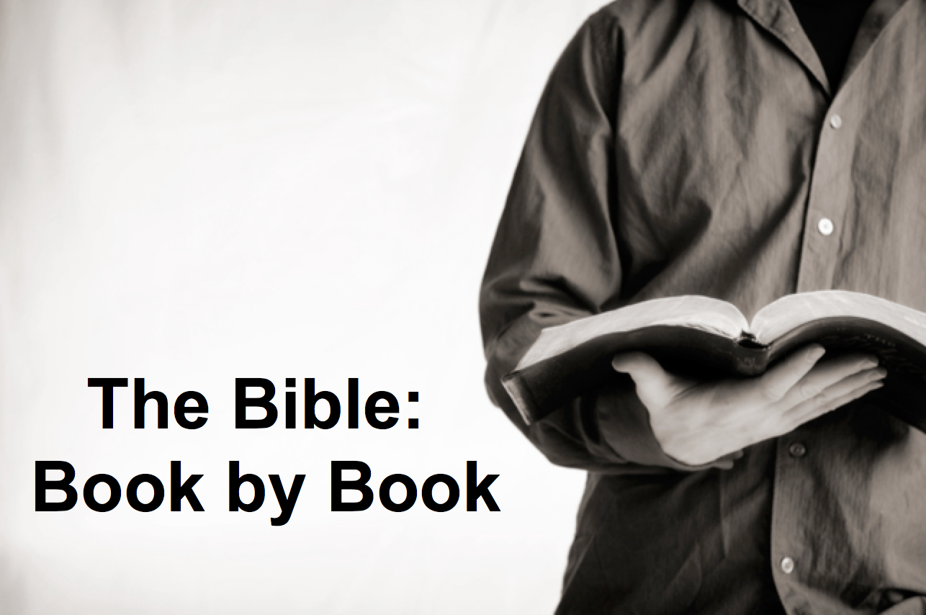

Rick Griffith
31 Dec 2017
Message 11 of 66

Be United
Book of 1 Kings

Introduction

Things sink without a good foundation. Is your spiritual foundation getting stronger?

Subject: Why does unity sometimes lead to division? What causes this to happen? The vital part is the foundation.

Main Idea: Our unity is only as strong as our _________ in Christ as our foundation.

The United Kingdom grew stronger and stronger from Saul to David to Solomon. But in 1 Kings we see that this foundation cracked beyond repair. Why?

__________________ leads to division (1 Kings 1–11; 971-931 BC).

The establishment of Solomon as king in his anointing and purging the kingdom of rivals confirms God's loyalty to the Davidic Covenant (1 Kings 1–2).

The rise of Solomon as king shows God's blessing upon him as the legitimate heir to the Davidic Covenant promises to show Israel in the benefits of following the Law (1 Kings 3–8).

The decline of Solomon from disobeying the Mosaic Covenant resulted in God opposing him

Ignoring God’s __________________ leads to division (1 Kings 12–22; 931-852 BC).

The kingdom divided under the idolatry and evil reigns of Jeroboam and Rehoboam to remind Israel to obey the Law rather than repeat the sins of the past (1 Kings 12–14).

The mixed reigns of two kings in Judah saw more idolatry then its removal from the land (15:1-24).

God judged the evil reigns of five kings in Israel for disobeying the Law (15:25–16:28).

The prophets Elijah and Micaiah confronted wicked Ahab of Israel to show the LORD's sovereignty over Baal (16:29–22:40).

Jehoshaphat's good reign in Judah purged the male shrine prostitutes and lacked only removal of the high places (22:41-50).

Ahaziah's evil reign in Israel continued the Baal worship begun by Ahab (22:51-53).

Conclusion

Our unity is only as strong as our ___________ in Christ as our foundation (Main Idea).

How can you put the Lord first by putting his Word first in the coming year?

Download this sermon PPT and notes for free at BibleStudyDownloads.org/resource/old-testament-preaching/
Listen to this message online at cicfamily.com/sermon-listing/

1 Kings

Division of the Kingdom

Late United Kingdom |  |  | Early Divided Kingdom
Chapters 1–11 |  |  | Chapters 12–22
Solomon |  |  | Split
Mostly Obedience |  |  | Mostly Disobedience
Yahweh Worship |  |  | Idol Worship
Kingdom in Tranquility |  |  | Kingdoms in Turmoil
Single Capital: Jerusalem |  |  | Israel’s Capital: Samaria  Judah’s Capital: Jerusalem
40 Years  (971-931 BC) |  |  | 80 Years  (931-852 BC)
Established: Purging  1–2 | Rise: Obedience  3–8 | Decline:  Disobedience  9–11 | “J & R”  Kings  12–14 | Other  Kings  15:1–16:28 | Ahab vs. Elijah  16:29–22:40 | Other  Kings  22:41-53

Key Word: Division

Key Verse: “But I will not take the whole kingdom out of Solomon’s hand; I have made him ruler all the days of his life for the sake of David my servant, whom I chose and who observed my commands and statutes. I will take the kingdom from his son’s hands and give you [Jeroboam] ten tribes” (1 Kings 11:34-35).

Summary Statement:
Solomon’s prosperity from loyalty to the Law ends in disobedience that causes the division of the kingdom with mostly evil kings in Israel and Judah to remind Judah of God's loyalty to the Davidic Covenant and its own need to obey the Law.

Application:

The test of a true servant of God is the ability to end well.

Discerning people of God learn from the mistakes of their predecessors and do not repeat these sins themselves.

